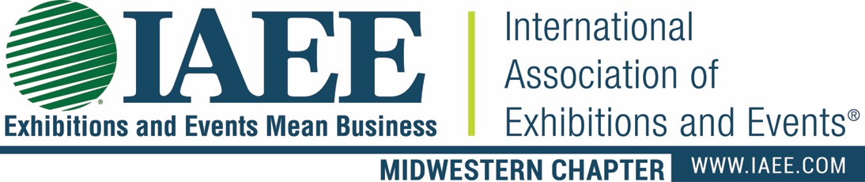

IAEE Midwestern Chapter - - CHARITY QUESTIONNAIRE

Organization Name: ____________________________________________________________________

Address __________________________________________City/State/Zip:_______________________

Phone ___________________________________ Web_______________________________________

Point of Contact _________________________________ Phone: ______________________________

Email _______________________________________

Please answer the following questions with as much detail as possible. Use additional paper if necessary.

- What is the annual operating budget?

- What percent of the budget goes directly to those you serve?

3. What organization or agency is your major supporter/donor?

- What is the geographical area that you serve?

- How many people do you serve annually?

- What hands-on volunteer opportunities exist for our members to assist?

- What are your organizations greatest needs?

- Does your organization collect specific products for its members (quarterly drive items)?

- What joint PR opportunities might exist?

- What is your largest fundraiser and when is it held?

- Do you publish a monthly newsletter or have a website?

IN ORDER FOR THE CHARITY TO BE CONSIDERED, PLEASE SUBMIT THE FOLLOWING ITEMS:

- Annual Report
- Brochures
Submit to: Gail Brooks, CMP
IAEE Midwestern Chapter Charity
1717 N. Naper Blvd., Suite 102
Naperville, IL 60563
Ph: 630-416-1166 Fax: 630-689-9034
gbrooks@wmrhq.com
- Newsletter

Deadline for application submission is Monday, August 31, 2020

