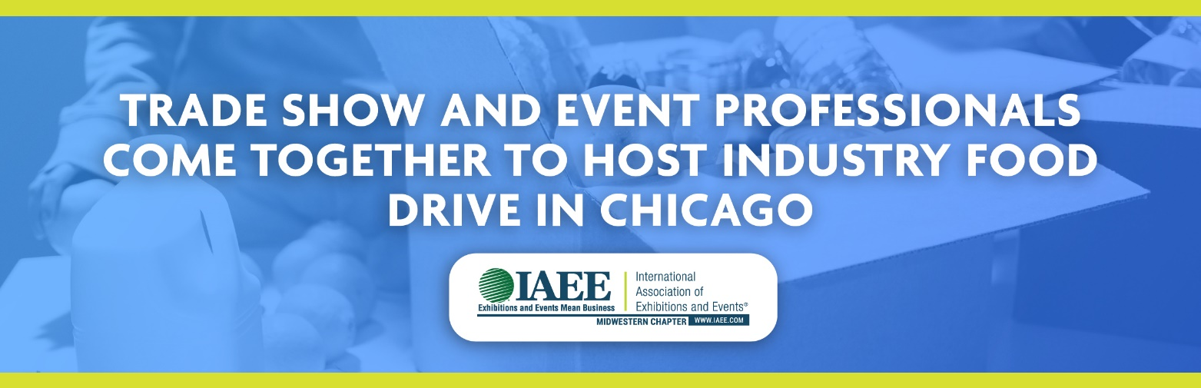

COVID-19 has brought the trade show and event marketing industry to a near standstill. While the entire industry has been hit hard, those in Chicago have been among the most affected.
A group of event professionals is coming together to organize a pop-up food drive in Chicago on April 30. With full support from the Greater Chicago Food Depository, this food drive is for trade show and event marketing industry people by trade show and event marketing industry people.
“We’ve been working with people from every corner of the event sector and know that the suffering from lack of work is significant,” said Martha Donato, founder and President of MAD Event Management LLC. "Our virtual food drive makes it easy to help tradeshow and event industry families. With just a few clicks, you can purchase nutritious fresh produce and protein and make a difference in the lives of our community in need."
The goal is to help those in trade shows and events who are experiencing difficult times and, at the very least, let them know that they haven’t been forgotten. Members of this group recently held a similar food drive in Las Vegas that helped nearly 300 families put food on their tables.
"For every $1 donated the Food Depository is able to provide 3 meals AND all donations made through our virtual drive will be used to purchase food for our community in need," added Donato. "Our goal is to raise $10,000. Please join us in this effort to help our community."
Please give now at https://www.myfooddrive.org/drive.php?tradeshows
Questions? Contact:

Martha Donato, President
MAD Event Management LLC
martha@madeventmanagement.com
Jen LaBruzza, National Sales
Classic Exhibits
jen@classicexhibits.com
Tom Mitchell, President
Messe Düsseldorf North America
tmitchell@mdna.com

